1)Install git.

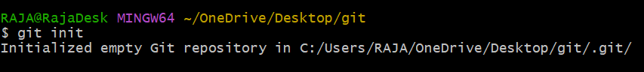

2)Create a repo in GitHub with README.md and .ignore file.

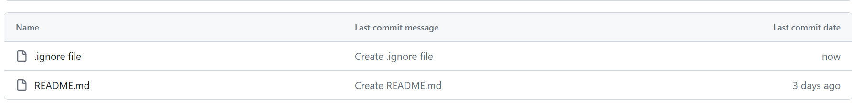

3)Clone the created repo to local.

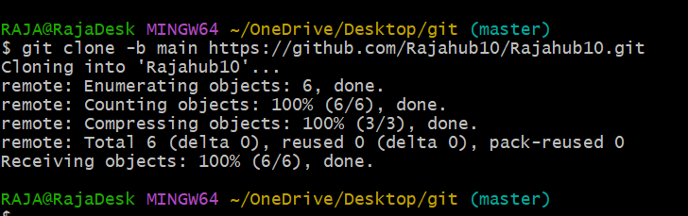

4)Create two files in local repo.

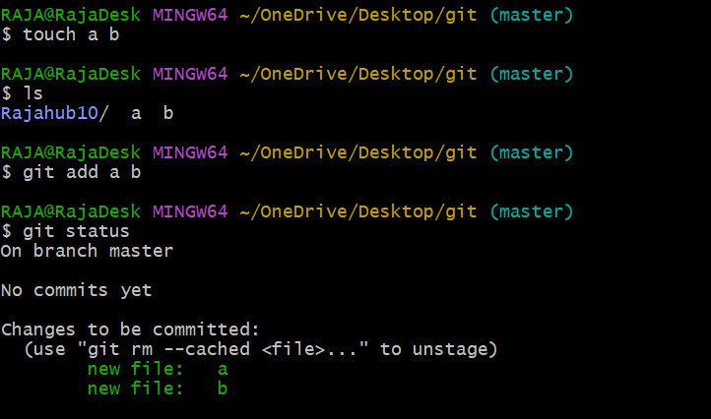

5)Commit two files and push to central Repository.

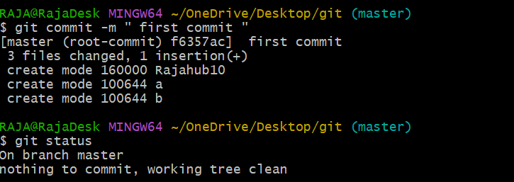

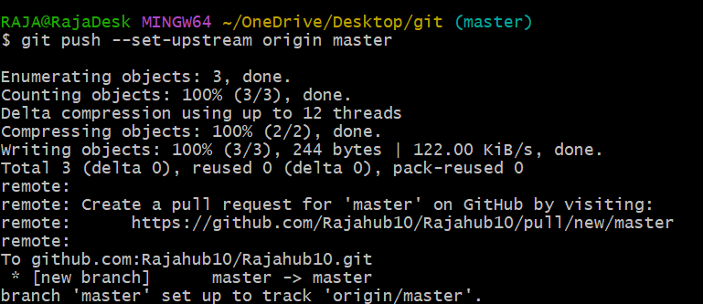

6)Create a branch in local and create a sample file and push to central.

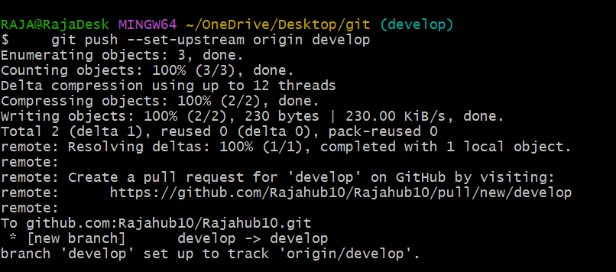

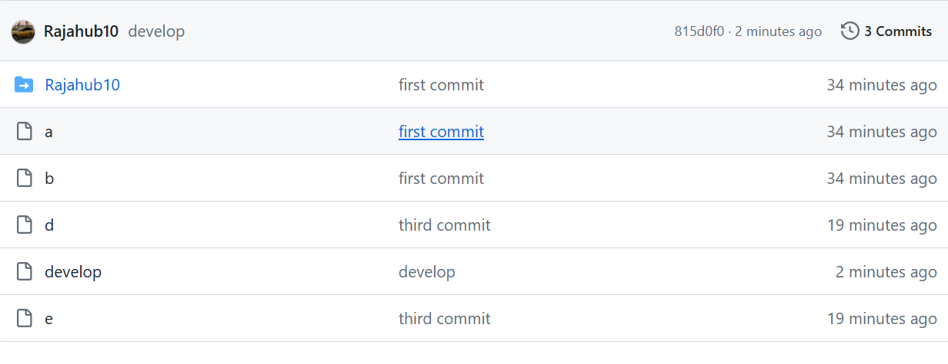

7)Create a branch in github and clone that to local.

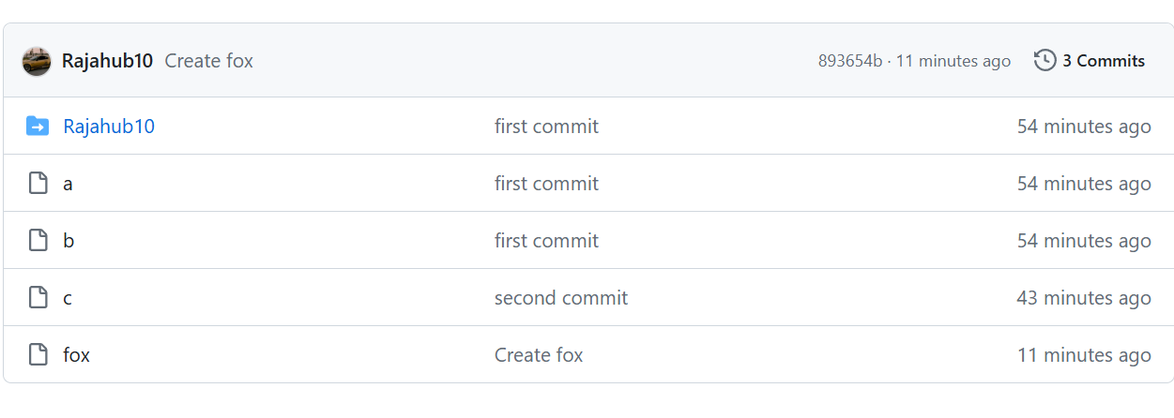

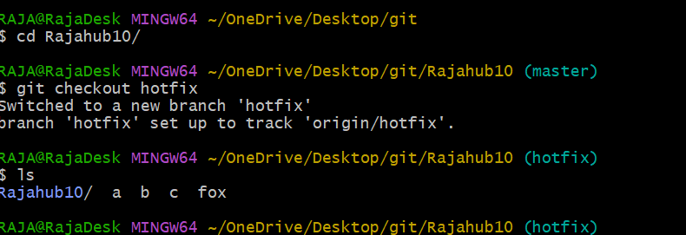

8)Merge the created branch with master in git local

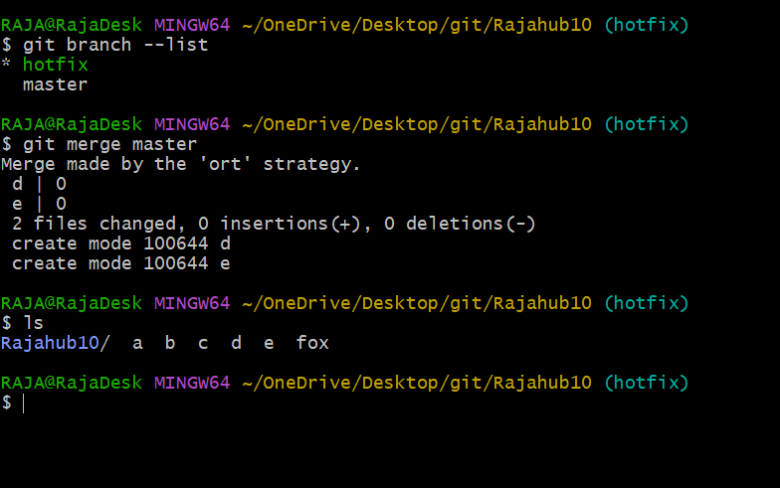

9)Merge the created branch with master in github by sending a pull request.

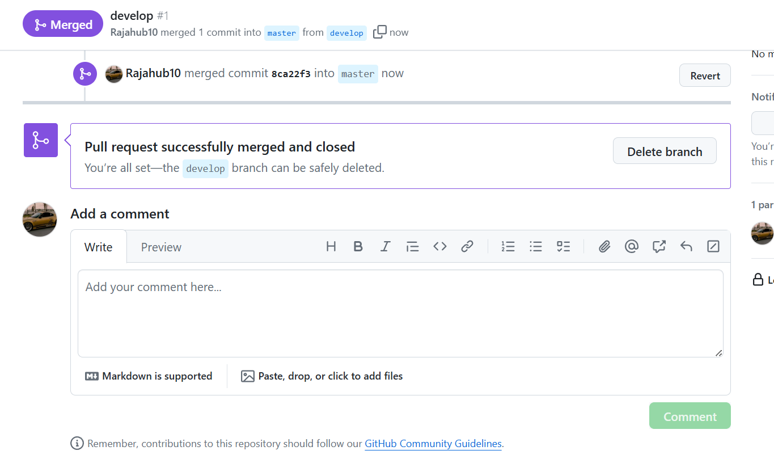

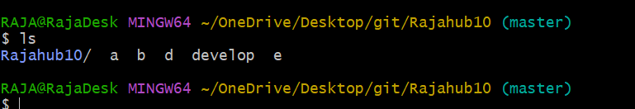

10)create a file in local and send that to branch in github.

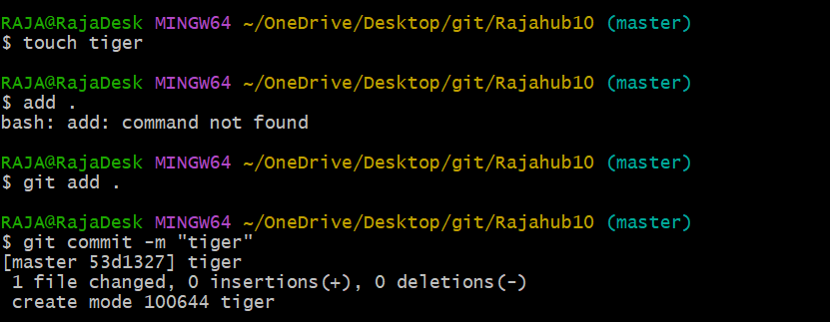

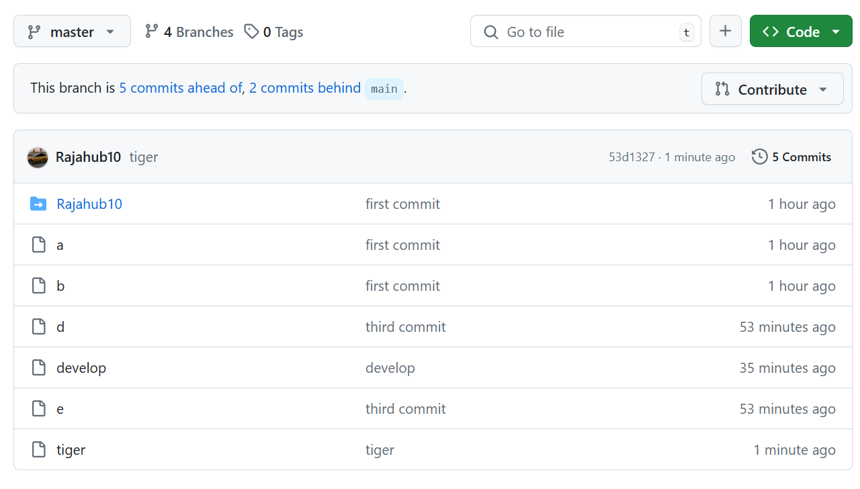

11)clone only a branch from github to local.

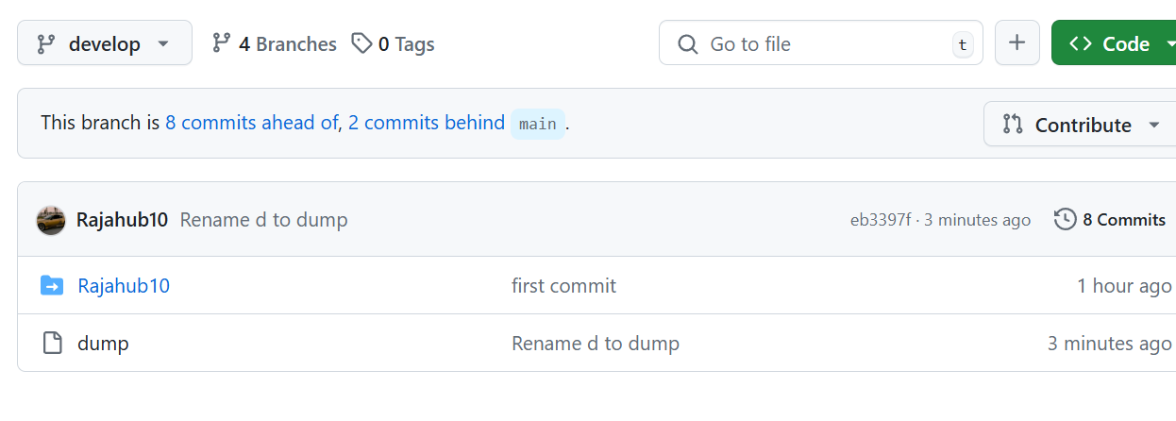

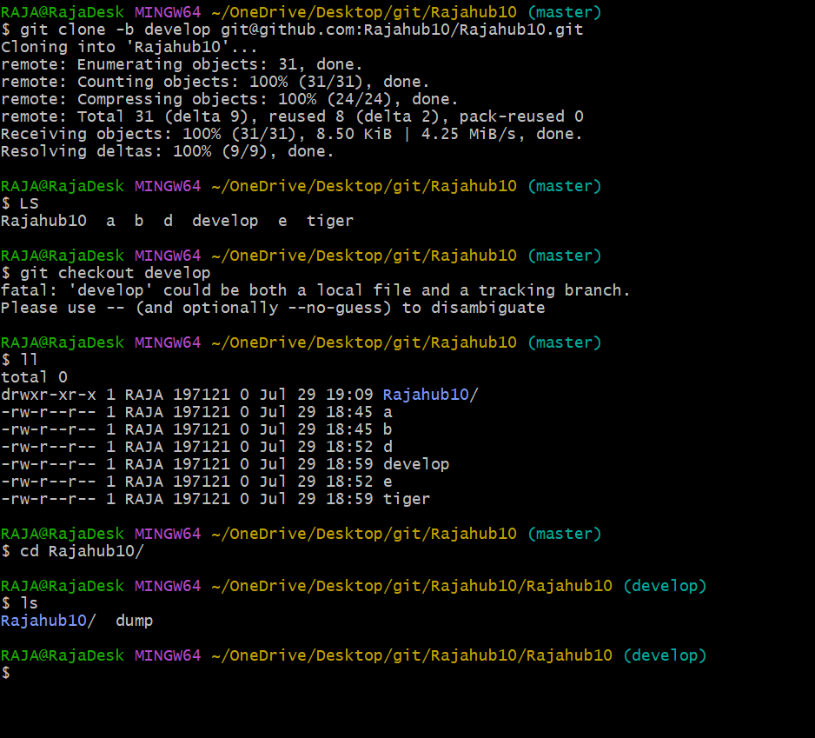

12)create a file with all passwords and make that untrack able with git.

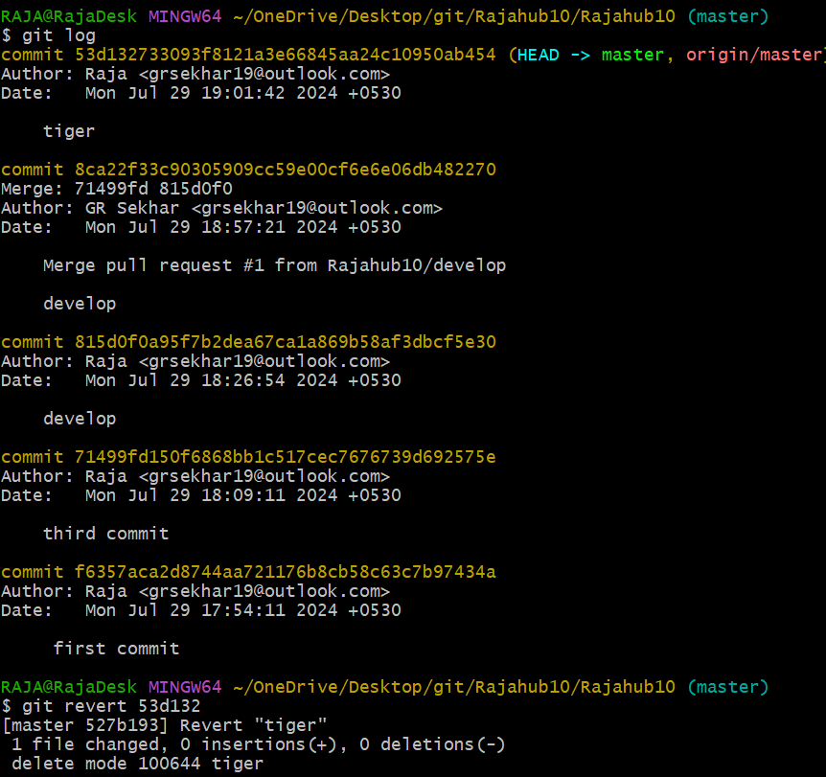

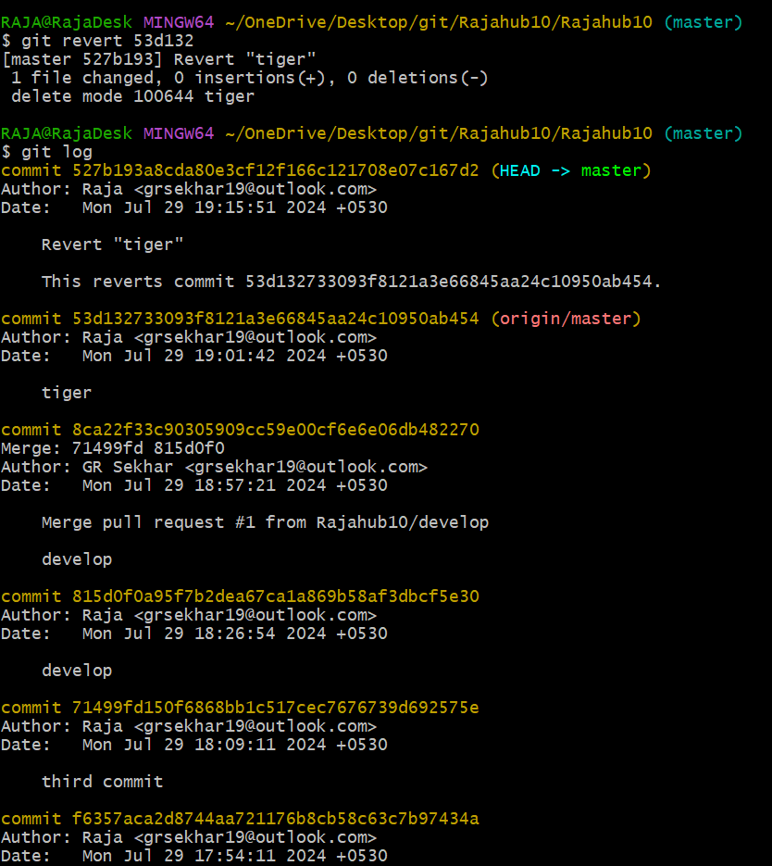

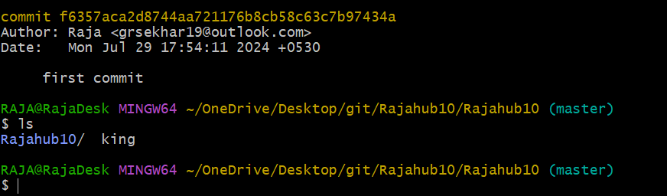

**13)make a commit and make that commit reset without savings changes.**

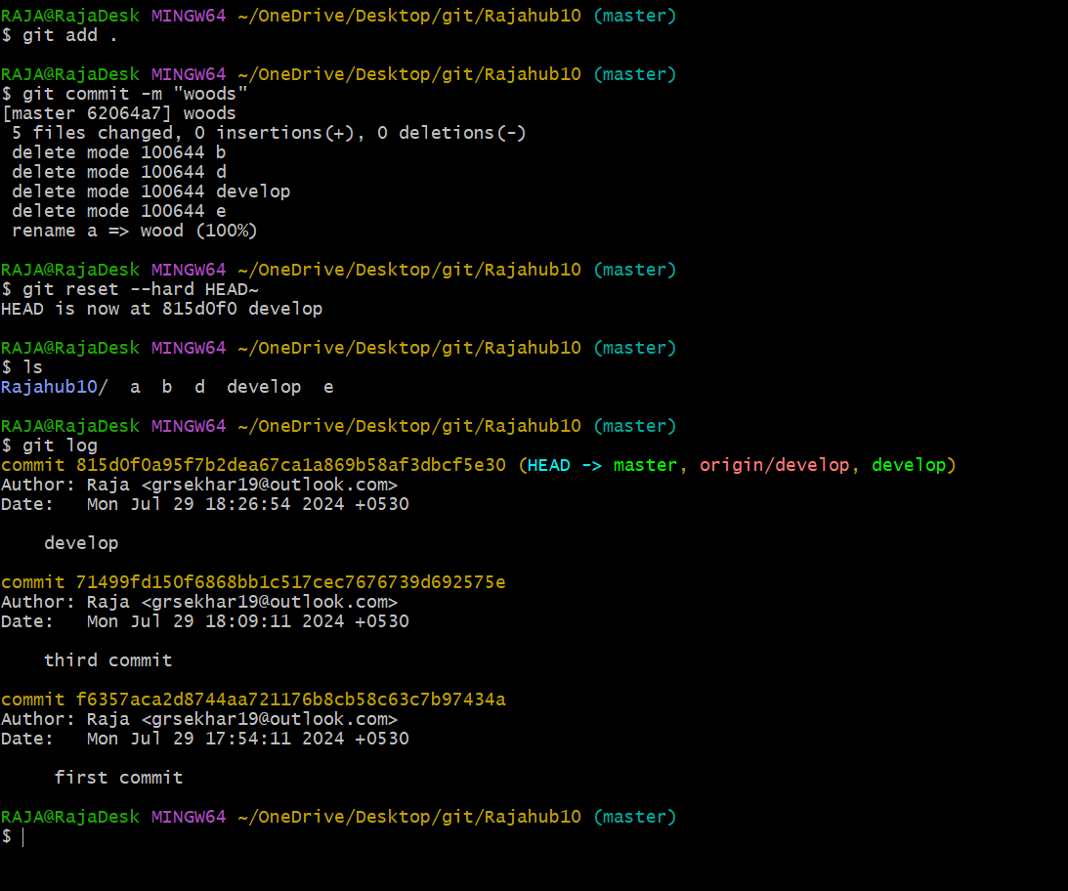

**14)Revert a commited commit to the older version.**

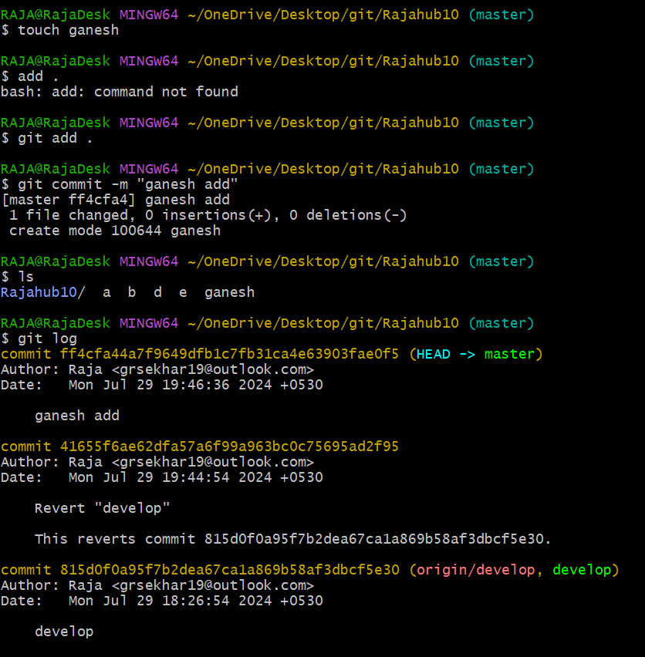

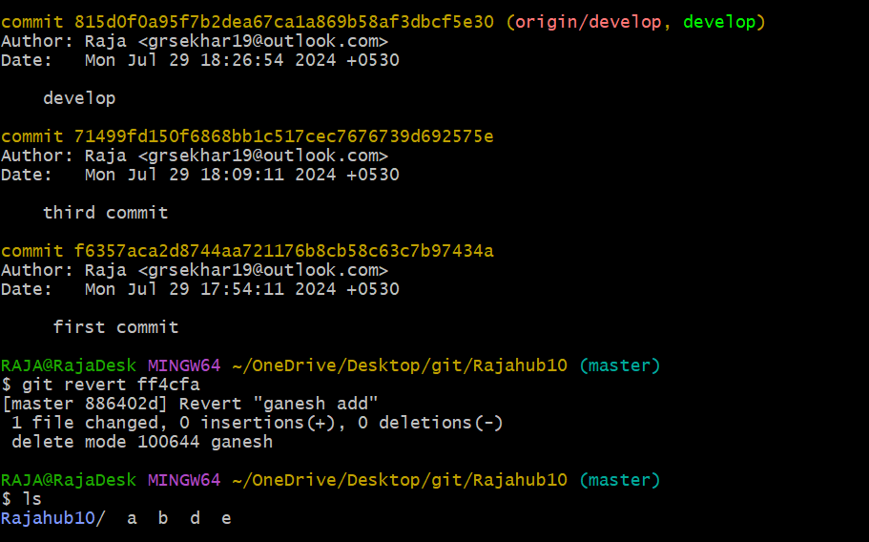

**15)push a file to stash without savings the changes and work on another file.**

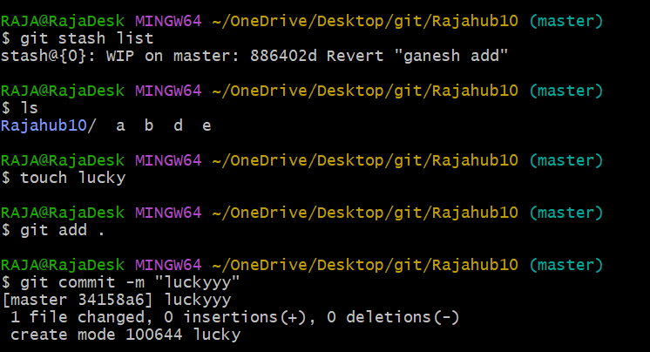

**16)undo the stash file and start working on that again.**

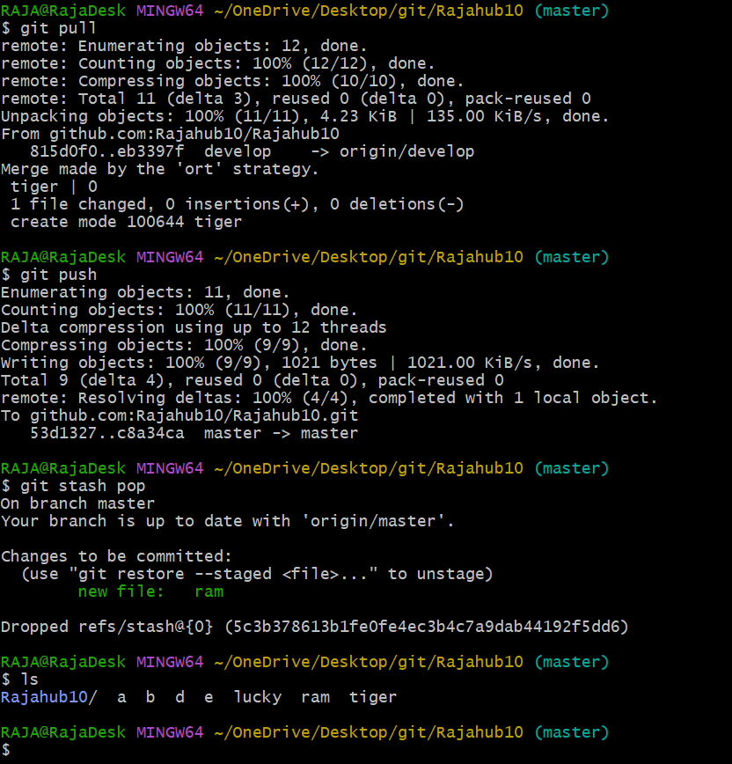

**17)generate a ssh-keygen and configure into github.**

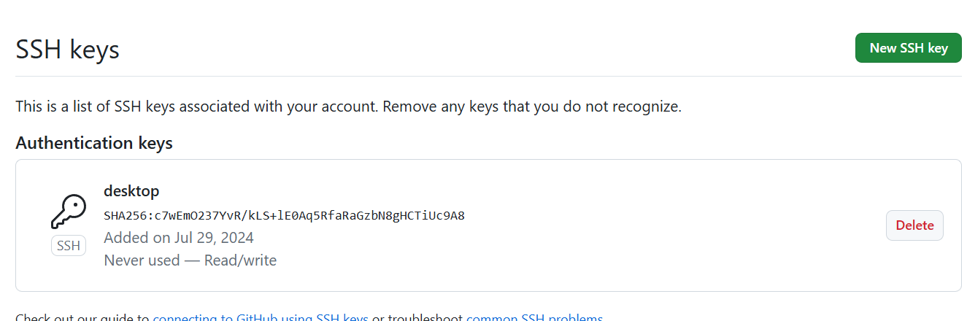

**20)Check all the logs of git.**

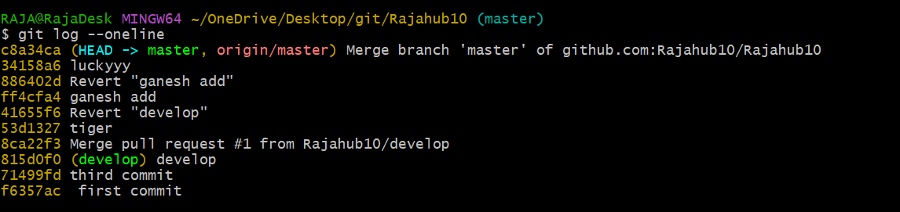

**21)Rename the commit message.**

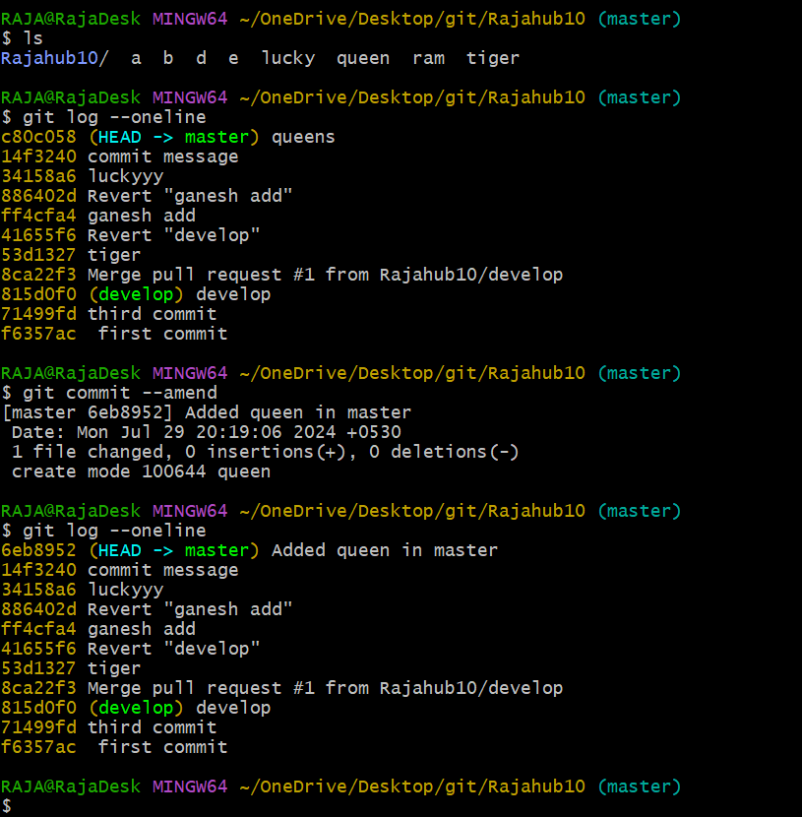

**22)Merge multiple commits into single commit**

